**CS2023 - Inclass Lab**

**Week 10 – Graphs**

**Vithurshan P.**

**210676M**

* **Section 1**
  + **1) Adjacent list**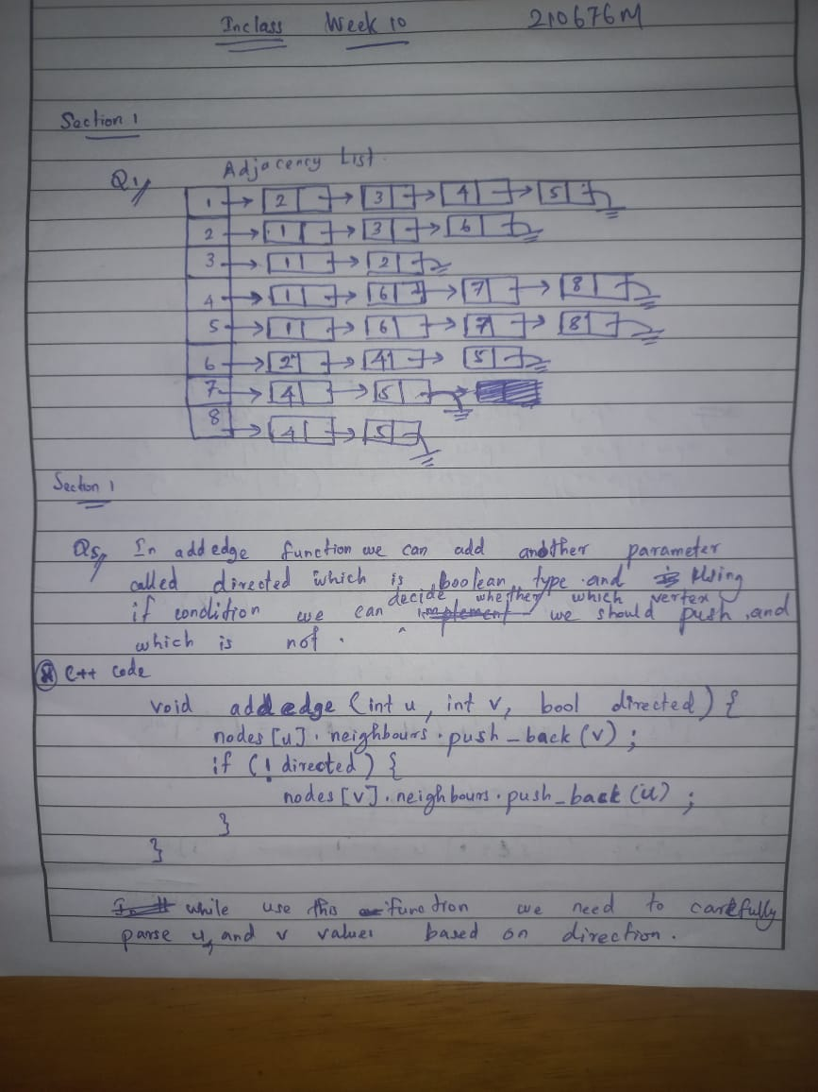

**4) Screen Shot of Adjacent list**

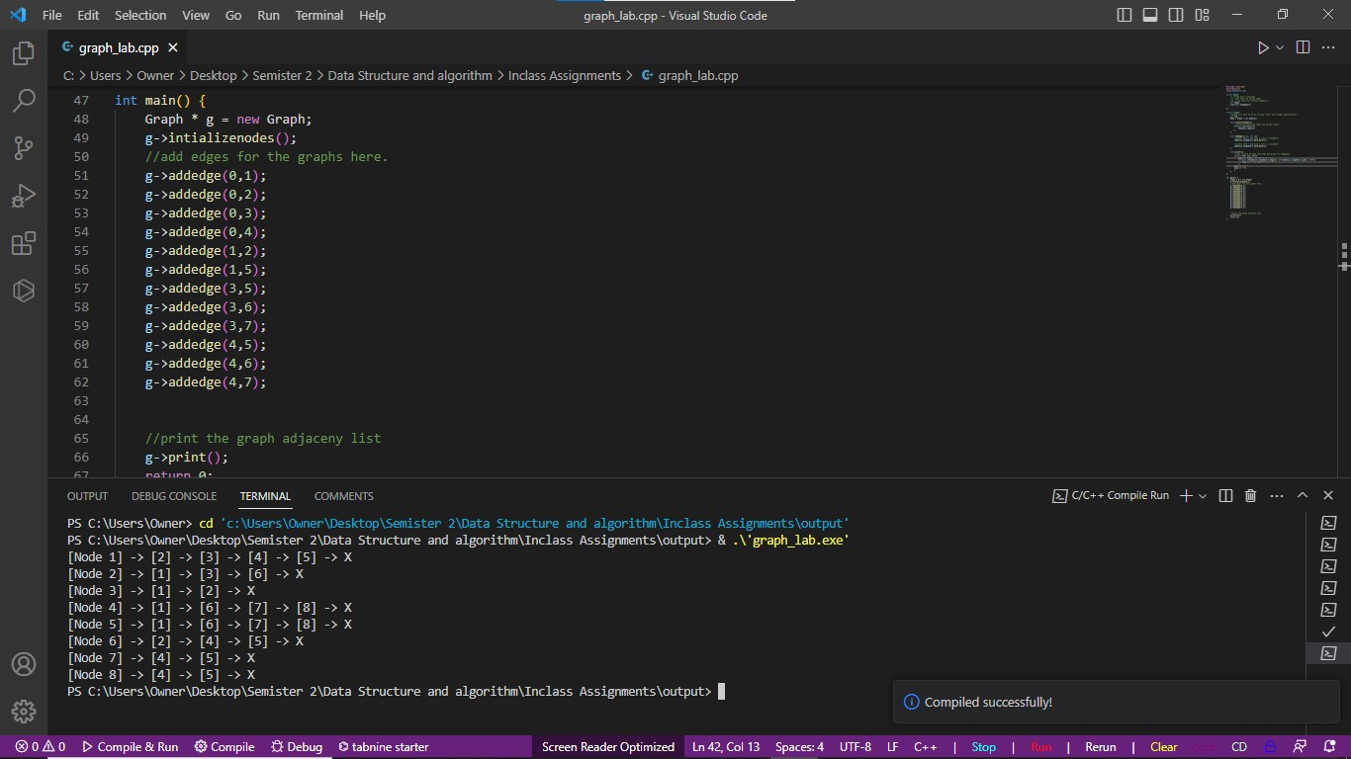

**5) **

**this code will work for both directed and undirected graphs.**

void addedge(int u, int v , bool directed){

    nodes[u].neighbours.push_back(v);

    if (!directed){

        nodes[v].neighbours.push_back(u);

    }

}

* **Section 2**

